APPLICATION
Absolut Champion of Croatia (AP CH HR)
DOG DETAILS
Breed
Dog name
Pedigree number |  | Born

OWNER DETAILS
Name
Surname
Address
E-mail |  | Cell phone

 | DATE OF THE DECLARATION | REFERENCE NUMBER OF CHAMPIONSHIP  (number in left corner of the certificate)
CH HR
CH HR R

DO YOU WANT THE ORNAMENT DIPLOMA ALSO TO BE MADE | YES | NO
Fee for the creation of CERTIFICATE is 25 € + Fee for the ornament DIPLOMA is 25 €
Payment can be done to bank account or with credit card.

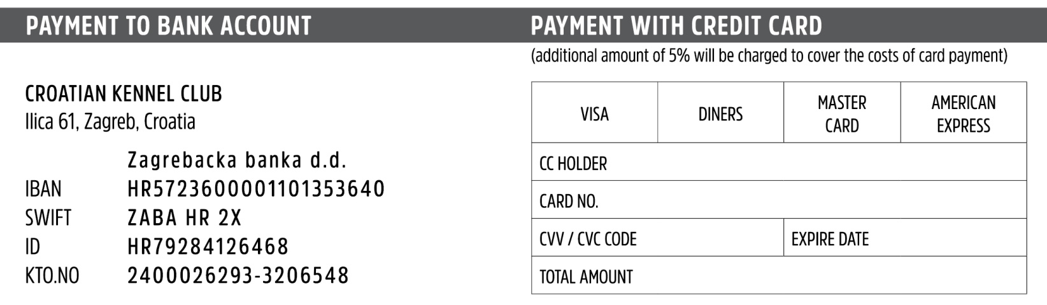
Place and date ____________________________ Signature ____________________________

