APPLICATION
Future Hope of Croatia
DOG DETAILS
Breed
Dog name
Pedigree number |  | Born

OWNER DETAILS
Name
Surname
Address
E-mail |  | Cell phone

DOG SHOW |  | SHOW DATE | TITLE ON SHOW | JUDGE
1.
2.
3.

DO YOU WANT THE ROSETTE ALSO TO BE MADE | YES | NO

Fee for the creation of CERTIFICATE is 25 € Rosette is free of charge
Payment can be done to bank account or with credit card.
Dogs with titles of CROATIAN FUTURE HOPE are not eligible to be entered into Champion Class at shows !

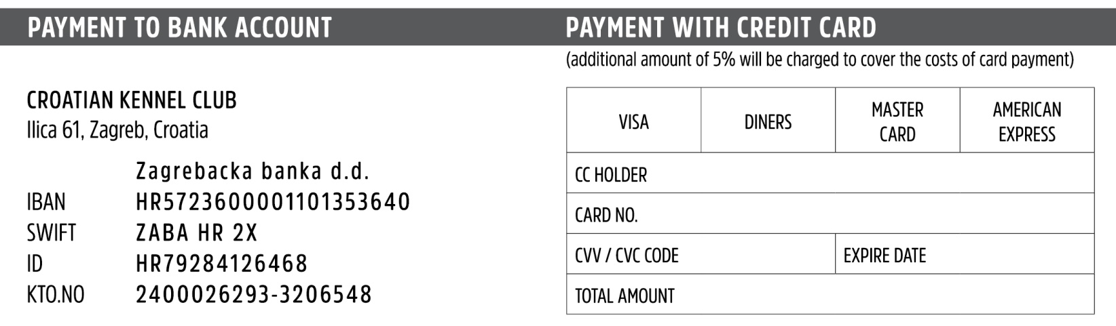
Place and date ____________________________ Signature ____________________________

