APPLICATION
Croatian Champion in Work (CH HR R)
DOG DETAILS
Breed
Dog name
Pedigree number |  | Licence number
Born |  | Sex

OWNER DETAILS
Name
Surname
Address
E-mail |  | Cell phone

WORK TRIALS
Trial |  | Date & Place | Title | Judge
1.
2.
3.

EVALUATION OF FORM
Show |  | Date | Grade | Judge
1.

DO YOU WANT THE ORNAMENT DIPLOMA ALSO TO BE MADE | YES | NO
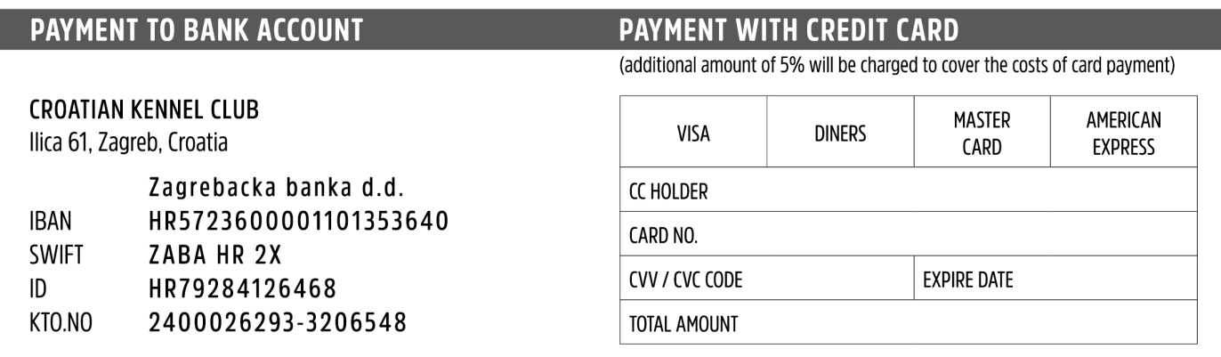
Place and date ____________________________ Signature ____________________________
Fee for the creation of CERTIFICATE is 25 € + Fee for the ornament DIPLOMA is 25 €
Payment can be done to bank account or with credit card.

