DUPLICATE OF EXPORT PEDIGREE
DOG DETAILS
Breed
Dog name
Pedigree number |  | Microchip / tattoo number
Born |  | Sex

OWNER DETAILS
Name
Surename
Address
E-mail |  | Cell phone

Duplicate of the export pedigree is being issues at request of OWNER / BREEDER (please circle)
Fee for the duplicate of export pedigree is 50 €
Payment can be done to bank account or with credit card

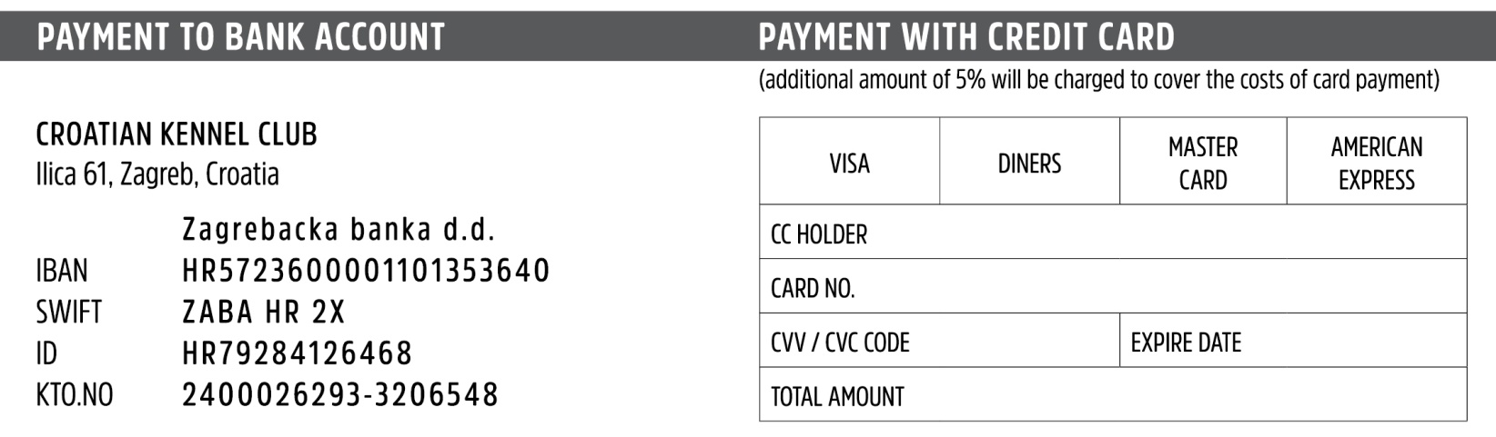
Date and place Signature

