APPLICATION
Future Hope of Croatia
DOG DETAILS
Breed
Dog name
Pedigree number |  | Born

OWNER DETAILS
Name
Surname
Address
E-mail |  | Cell phone

DOG SHOW |  | SHOW DATE | TITLE ON SHOW | JUDGE
1.
2.
3.

DO YOU WANT THE DIPLOMA ALSO TO BE MADE | YES | NO

Fee for the creation of CERTIFICATE is 25 € DIPLOMA is free of charge
Dogs with titles of CROATIAN FUTURE HOPE are not eligible to be entered into Champion Class at shows !

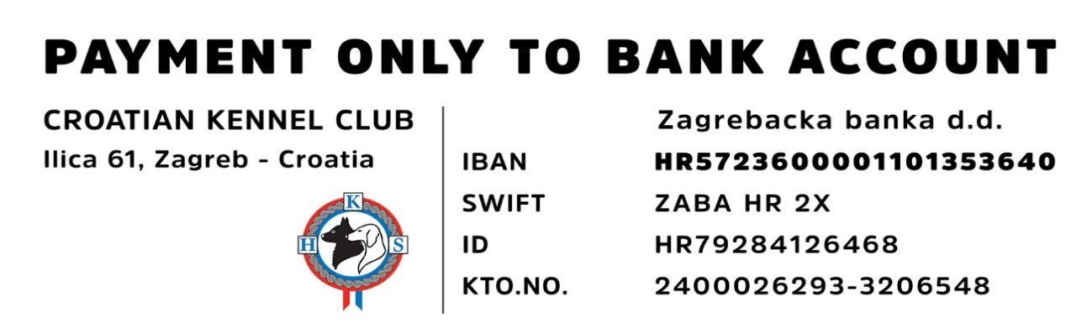
Place and date ____________________________ Signature ____________________________

