APPLICATION
Croatian Grand Champion (CH HR G)
DOG DETAILS
Breed
Dog name
Pedigree number |  | Born

OWNER DETAILS
Name
Surname
Address
E-mail |  | Cell phone

DOG SHOW |  | SHOW DATE | TITLE ON SHOW | JUDGE
1.
2.
3.
4.

CH HR / CH HR I | DATE OF THE DECLARATION | REFERENCE NUMBER OF CHAMPIONSHIP  (number in left corner of the certificate)

DO YOU WANT THE ORNAMENT DIPLOMA ALSO TO BE MADE | YES | NO
Only diploma fee is being charged, certificate is free of charge
Fee for the ornament DIPLOMA is 25 €
Payment can be done to bank account or with credit card.

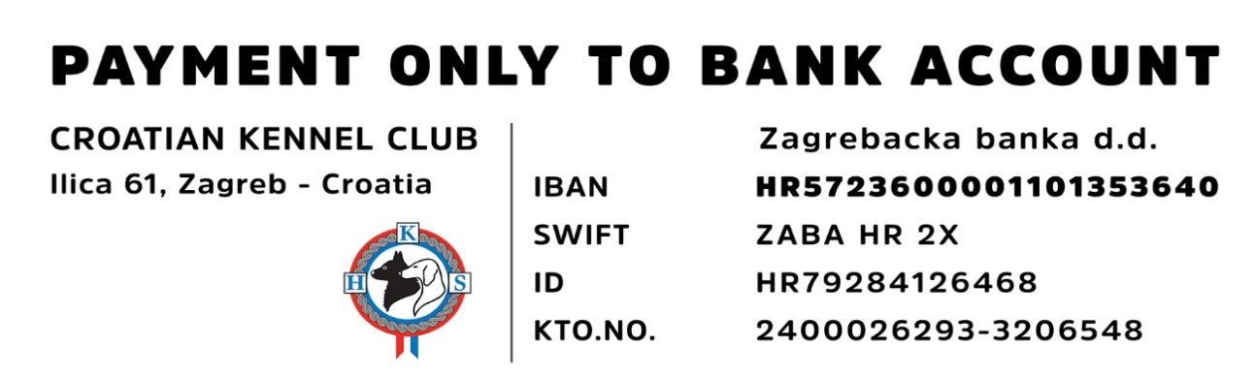
Place and date ____________________________ Signature ____________________________

