APPLICATION
Croatian Junior Champion (CH M HR)
DOG DETAILS
Breed
Dog name
Pedigree number |  | Born

OWNER DETAILS
Name
Surname
Address
E-mail |  | Cell phone

DOG SHOW |  | SHOW DATE | TITLE ON SHOW | JUDGE
1.
2.
3.

DO YOU WANT THE ORNAMENT DIPLOMA ALSO TO BE MADE | YES | NO

Fee for the creation of CERTIFICATE is 25 € + Fee for the ornament DIPLOMA is 25 €
Dogs with titles of CROATIAN JUNIOR CHAMPION in Beauty are not eligible to be entered into Champion Class at shows !

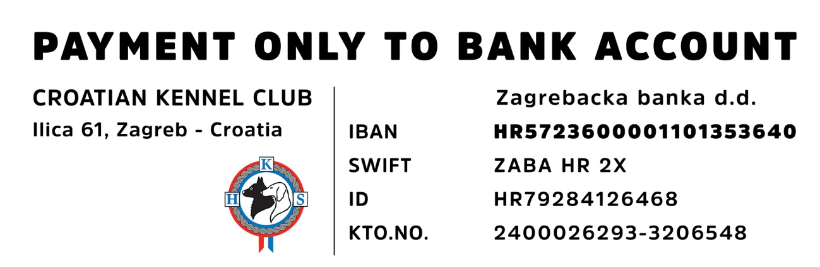
Place and date ____________________________ Signature ____________________________

