EXPORT PEDIGREE
DOG DETAILS
Breed
Dog name
Pedigree number |  | Microchip / tattoo number
Born |  | Sex

OWNER DETAILS
Name
Surename
Address
E-mail |  | Cell phone
Fee for the export pedigree is 50 €
Payment can be done to bank account or with credit card

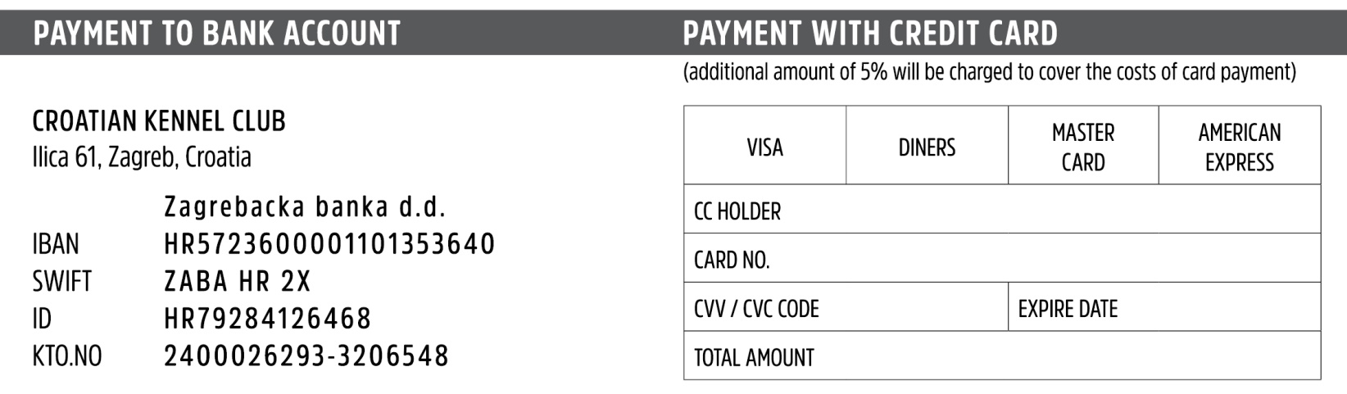
Date and place Signature

